# **OOO: In the Woods**

### Turn on your away message and go outside

Zoe's avatar

[Zoe](https://substack.com/@zoeffc)

Feb 28, 2025

2

1

Share

Hi there,

On Wednesday, I took a half day and went into the woods. Thank you, 4 hours of sick time.

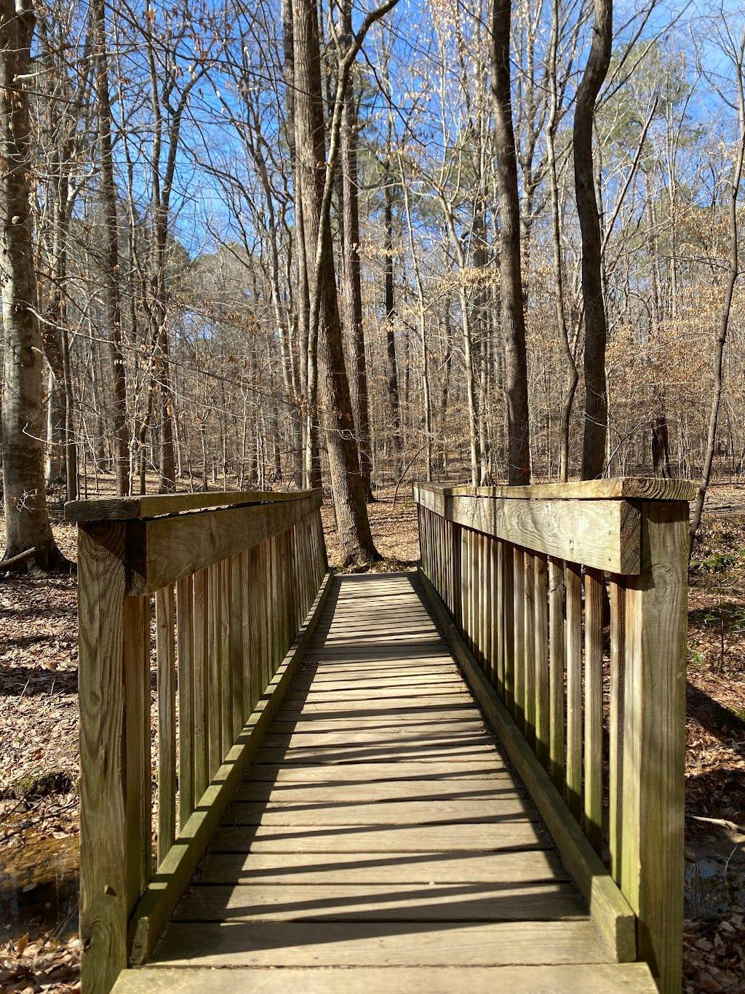

Into the woods we go! Come with me across the bridge.

Things I noticed:

* there were absolutely no leaves on the trees
* it was about 65 degrees outside and I was in a tee-shirt, so I got to feel the sun and the wind on my bare arms
* The ground was covered in pine needles
* I was constantly tripping over knobby roots

Subscribed

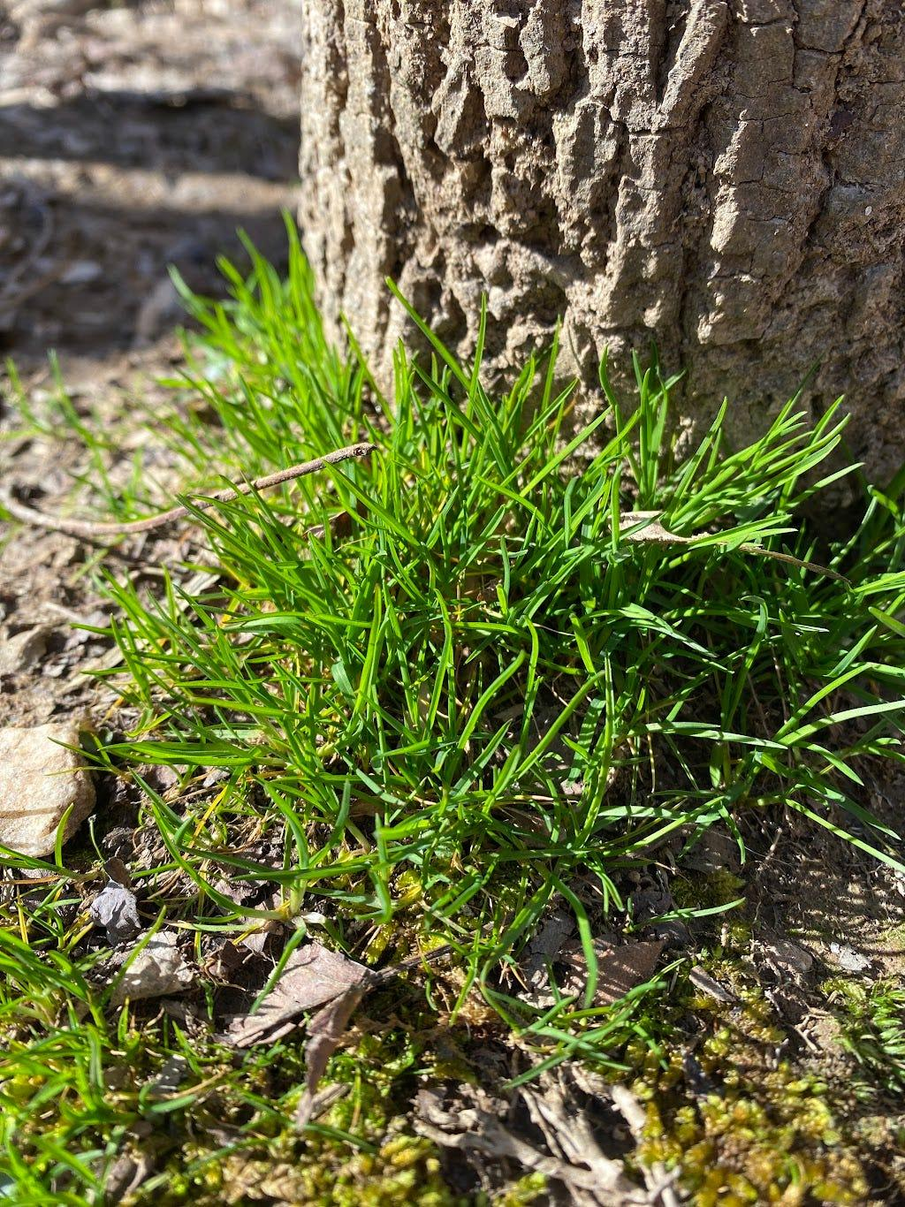

There may not have been leaves, but there were all of these little patches of grass. Look how vibrant!

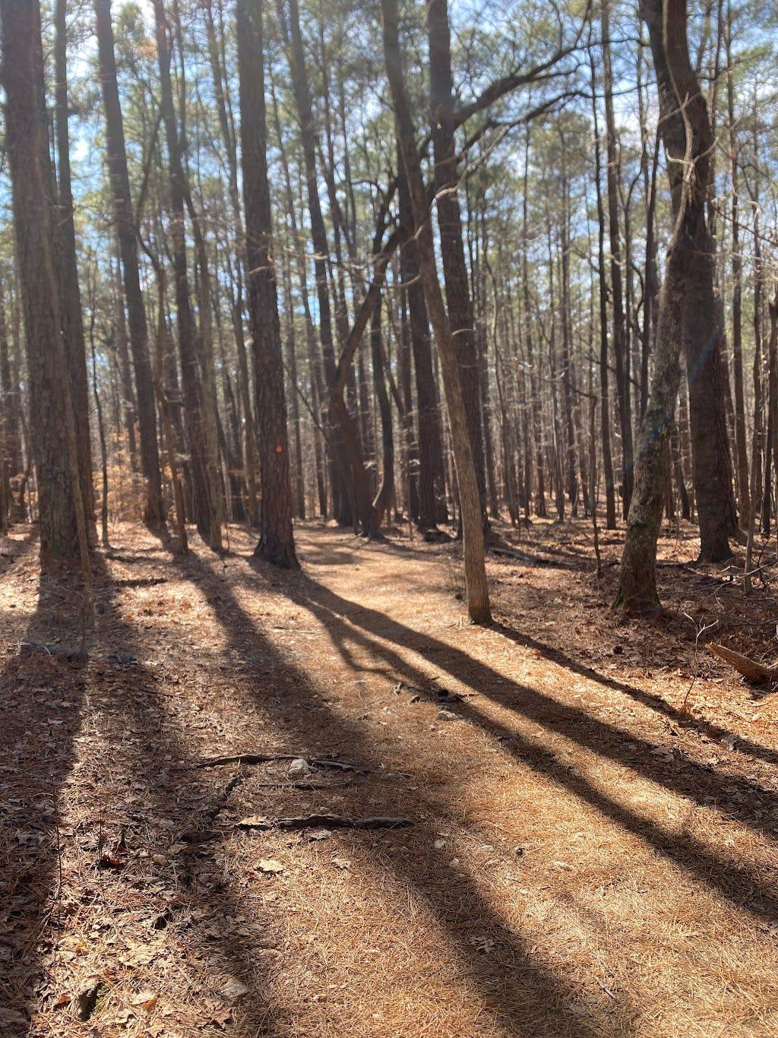

Ooo ahh trees… And a blurry photo taken too quickly. Oops.

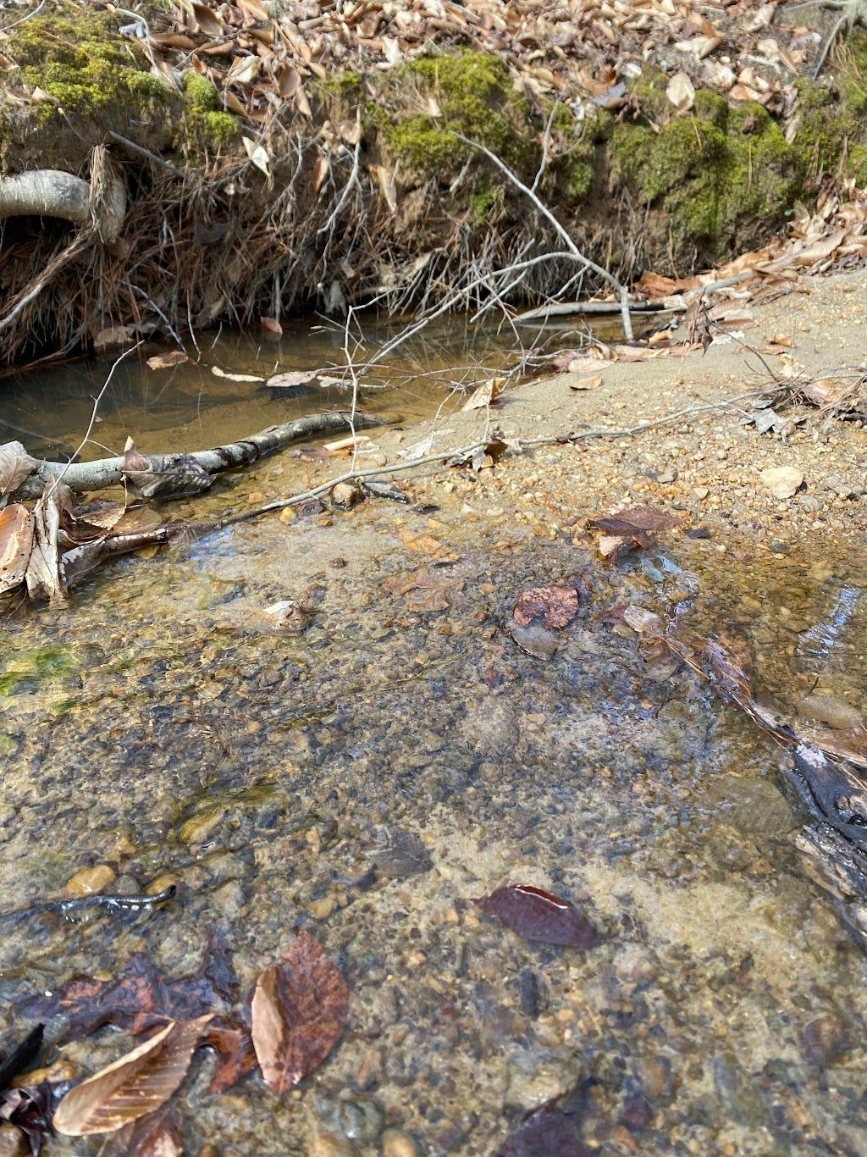

Guys, it’s a literal babbling brook.

Anyway, I will get back to you next week. Maybe go outside in the meantime.

Best,

Zoe